Problem Set 4
MGMT 405 – Managerial Economics Prof. Nico Voigtländer
Covers Modules 5 and 6 · 100 points · Due date: see the Course Calendar on the Class Website
Please upload one solution per group on the course BruinLearn site or email the group solution to the TA.
Please address all questions about this Problem Set to the TA Rafael Macedo
Important information, please read carefully
AI tools policy for problem sets: For problem sets, you may use AI tools (e.g. ChatGPT) to help brainstorm or to revise existing work you have written. When you submit your problem set, we expect you to clearly attribute what text was generated by the AI tool (e.g., AI-generated text appears in a different colored font, quoted directly in the text, or use an in-text parenthetical citation). We will screen for undisclosed AI-generated content using advanced AI-detection programs. While AI tools can provide helpful insights, we want you to think critically about the information you receive. Think of AI tools as a study partner who can help you dive deeper into the concepts behind each problem set exercise. You will have to prove your understanding in the midterm and final exams, where the use of AI tools will be prohibited.
Problem 1. Maguire Alarm Company (25 points)
Draws on: Module 5 – Monopoly; Module 6 – Complex Pricing (the Lerner Index)
The Maguire Alarm Company is a medium-sized electronics company specializing in alarm devices. Maguire’s demand function is estimated as $Q=4,500−P$, and the company has the following cost function:
$$TC=150,000+400Q$$
Suppose that the current sales price is $2,000 per unit.
(a) (4 points) What is the current level of profits at this price?
(b) (4 points) What is the own-price elasticity at the current price of $2,000? Is demand elastic or inelastic at this price?
(c) (12 points) What is the optimal quantity and price (at which profits are maximized)? What is the level of profits at this optimal price? What is the own-price elasticity of demand at this optimal price? Is demand elastic or inelastic at this price? Comparing your answers to (b) and (c), what does the firm’s position on the demand curve at $2,000 tell you about whether that price could have been profit-maximizing?
(d) (5 points) What is the share of markup in the optimal price (Lerner Index)? Show the two ways of computing the Lerner Index by relating it to the demand elasticity estimated in (c).
Problem 2. Dayna’s Doorstops (20 points)
Draws on: Module 5 – Monopoly; Module 4 – consumer surplus, producer surplus and deadweight loss
(From Pindyck and Rubinfeld.) Dayna’s Doorstops, Inc. (DD) is a monopolist in the doorstop industry. Its total cost is
$$TC=100−5Q+Q^{2}$$
and (inverse) demand is
$$P=55−2Q$$
(a) (5 points) What price should DD set to maximize profit? What output does the firm produce? How much profit does DD generate?
(b) (7 points) What would output be if DD acted like a perfect competitor and set MC = P? How much profit would DD generate?
(c) (8 points) Show graphically the consumer surplus and producer surplus under perfect competition (part (b)). Then draw a separate graph showing consumer and producer surplus under monopoly (part (a)). Illustrate on the second graph the deadweight loss due to monopoly. Explain in words the consequences of having a monopoly instead of perfect competition on consumer surplus, producer surplus, and on total welfare. Note: You do not need to plot the exact functions from (a) and (b); an illustration is fine. You may use AI tools to produce graphs.
Problem 3. Reinventing Barnes & Noble (20 points)
Draws on: Module 5 – Monopolistic Competition
James Daunt, the CEO of Barnes & Noble, was hired before the sales of Barnes & Noble reached the bottom. His goal is to change the business model of the company.
(a) (5 points) Describe how the market for books has changed since the early 2000s. What do you think are the reasons for the decline in the fortunes of Barnes & Noble?
(b) (5 points) Consider the following three demand curves. Which one represents the best approximation for the demand Barnes & Noble faces, and why? Use the concepts learned in class to describe the characteristics of the market in which Barnes & Noble operates.
Price
Output
P*
(A)
Price
Output
(B)
Price
Output
(C)
(c) (5 points) What does this type of demand curve imply about the ability of Barnes & Noble to increase the price of its products?
(d) (5 points) In a recent interview, James Daunt proposed to give more freedom to the individual bookstores:
“You should do what you want; there are no restrictions on what books you stock… Each bookshop is quite individual.”
— James Daunt, CEO of Barnes & Noble
Propose two strategies for bookstores to differentiate themselves from competitors. What does differentiation imply for the price elasticity of demand?
Two podcasts you might consider listening to, to know more about the business strategy of Barnes & Noble: The Verge — Decoder and NPR — How Barnes & Noble turned a page.
Problem 4. Avocado Pricing Strategy (20 points)
Draws on: Module 6 – Complex Pricing (third-degree price discrimination)
From 2015 to 2018, the demand for avocados (both conventional and organic) in Atlanta was
$$Q_{A}=730−175P_{A}$$
where quantity Q is in 1,000 per week and P_{A} is the average weekly price per avocado across all retailers. For the same time period, the demand for avocados in San Diego was
$$Q_{B}=855−319P_{B}$$
Again, Q is in 1,000 per week and the price is per avocado. The marginal cost of production is the same in both markets and equal to $0.17 per avocado.
Note: The fact that Q is given in 1,000 units should not affect any of your calculations. You can use the formulas and marginal cost exactly as given above, without multiplying or dividing by 1,000. Only at the end, when you interpret total quantity, total revenues or profits, note that all of those will be in 1,000. For example, if you compute total revenues of $5,000 those would actually correspond to $5,000,000. The price, however, is given per unit: if you compute an optimal price of $100 per unit, that is your final result. You may use AI tools to produce graphs; graphs do not need to be to scale, they can be used merely for illustration.
(a) (5 points) What is the optimal price to charge in Atlanta? Show your work both analytically and graphically.
(b) (5 points) What is the optimal price to charge in San Diego? Show your work both analytically and graphically.
(c) (3 points) What is the own-price elasticity of demand at the profit-maximizing prices in the two cities?
(d) (4 points) Do your findings in (a) and (b) (price in each market) and in (c) (own-price elasticity in each market) confirm what we learned in class about elasticities and price discrimination?
(e) (3 points) Explain which problems may result from the pricing structure that you have calculated in the previous questions. [A quantitative answer is not required. Hint: What if transportation costs are low relative to price differences?]
Problem 5. Working Interactively with AI: The Future of Work (15 points)
Draws on: Course-wide – marginal analysis applied to tasks; O*NET occupational data
Welcome to the AI & Labor Market Challenge. In this exercise you will collaborate with ChatGPT to explore how automation might reshape different occupations. Your task is to compute an index of exposure to AI for different jobs. You will use, interpret and may also challenge ChatGPT’s classification. Here are the step-by-step instructions.
Step 1 (2 points) — Choosing the Occupations
Go to the O*NET website (see the screenshot below) and identify two occupations from your team that are as different from each other as possible. The goal is to compare jobs that rely on different skills and tasks.
Note: If all team members have similar roles (for example, various types of managers), select one previous occupation or choose from this list: economist, lawyer, accountant, waiter/waitress, plumber, actor/actress, high-school teacher.
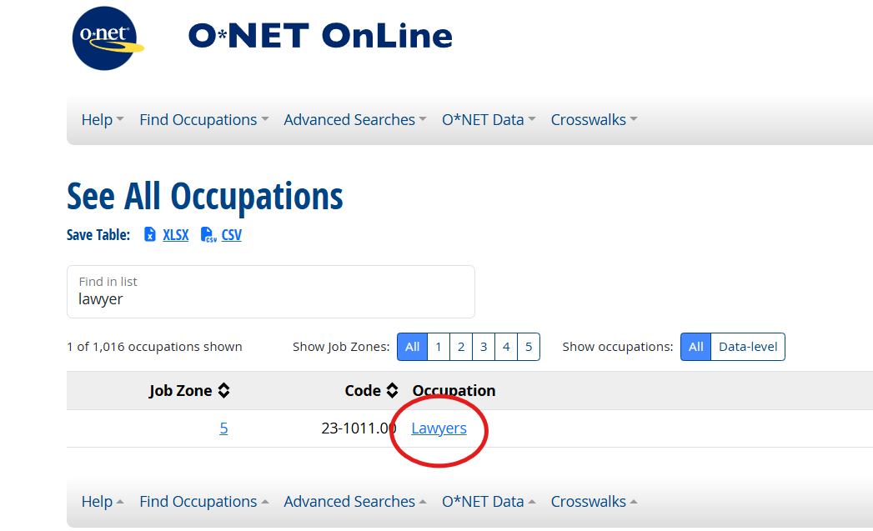
Step 2 (5 points) — Listing and Classifying Tasks
For each of the two chosen occupations, open the “Details → Tasks” tab in O*NET (see the screenshot below). Copy all core tasks for that occupation (supplemental tasks are not required), together with their importance scores (0–100), into an Excel spreadsheet.
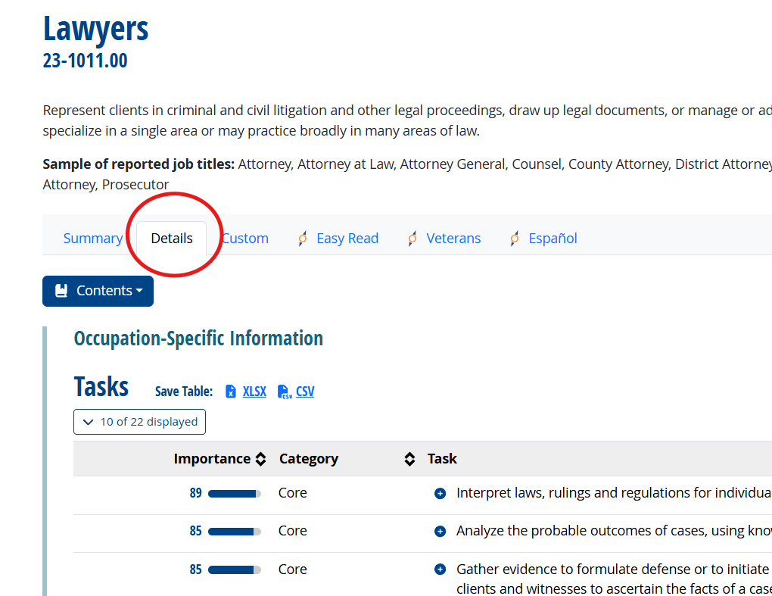
Paste this spreadsheet into ChatGPT (or any AI interface) and ask it to:
• Replacement dummy: Classify, for each profession, which task ChatGPT believes will be replaced by AI-supported automation in the next five years. Hint: ask ChatGPT to add a new column “Replacement dummy” of 1s and 0s, where 1 indicates that the task will be replaced.
– If you want a more finely-grained index, you could instead ask ChatGPT to classify the extent to which each task will be replaced: 0 for “none”, 0.25 “some replacement”, 0.5 “substantial replacement”, 0.75 “almost completely replaced” and 1 “completely replaced”. You will receive full credit for the simpler 0/1 dummy as well.
• Review ChatGPT’s classification. You may change its coding if you disagree. Report your final table with scores in your solutions. You do not need to document these steps: the idea is that you create an AI-supported coding of tasks, supported by your own judgment. You can of course ask ChatGPT for its reasoning behind each code.
Step 3 (8 points) — Computing the AI-Replacement Index
For each of the two occupations, compute an AI-Replacement Index using the importance score of each task as a weight:
$$AI Replacement Index=\frac{Σ(Importance×Replacement dummy)}{Σ(Importance)}$$
where Σ indicates “sum”. You may compute this in Excel, or ask ChatGPT to do the calculation. If the index equals 1, every single task of an occupation is replaceable by AI; a value of 0 implies that the occupation should be relatively safe from AI.
Compare the indexes for the two occupations. Which occupation appears more exposed to automation? Do you agree or disagree with this result? Discuss briefly.

